Ready to dismantle racism?

Race, Church, and Healing Workshops

April 19 - May 24, Monday Nights, 6:30-8:15pm EST on Zoom

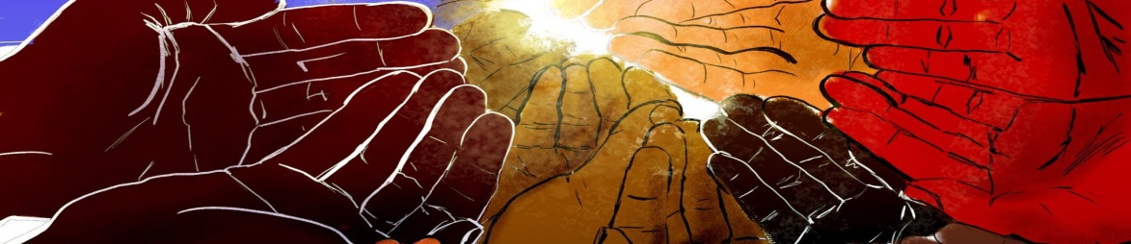

We invite you to a series of workshops designed to increase intercultural competence and understanding of systemic racism as individuals and groups.

- WEEK 1: Engaging Constructively in Brave Conversations about Race
- WEEK 2: The Myth of Race and Deconstructing the Myth of Whiteness
- WEEK 3: Race and Christianity – Decolonizing the Church
- WEEK 4: The Psychology of Racism
- WEEK 5: Exploring Intersectionality
- WEEK 6: Putting It All Together and Restorative Healing and Self-Care
- COST: FREE admission
**Donations are welcomed to offset costs so that we can provide an educational opportunity for all. A suggested donation of $35 per person is encouraged.

REGISTER: Race, Church & Healing Workshop Series
DONATE: Race, Church & Healing Donation -then under "FUND" choose "Racial Unity Missions." Thank you!

***Sponsorship Opportunities are still available! Please contact WUMCRacialUnity@gmail.com for more information***
